**Vprofile App on AWS Services (PAAS & SAAS)**

Architecture:

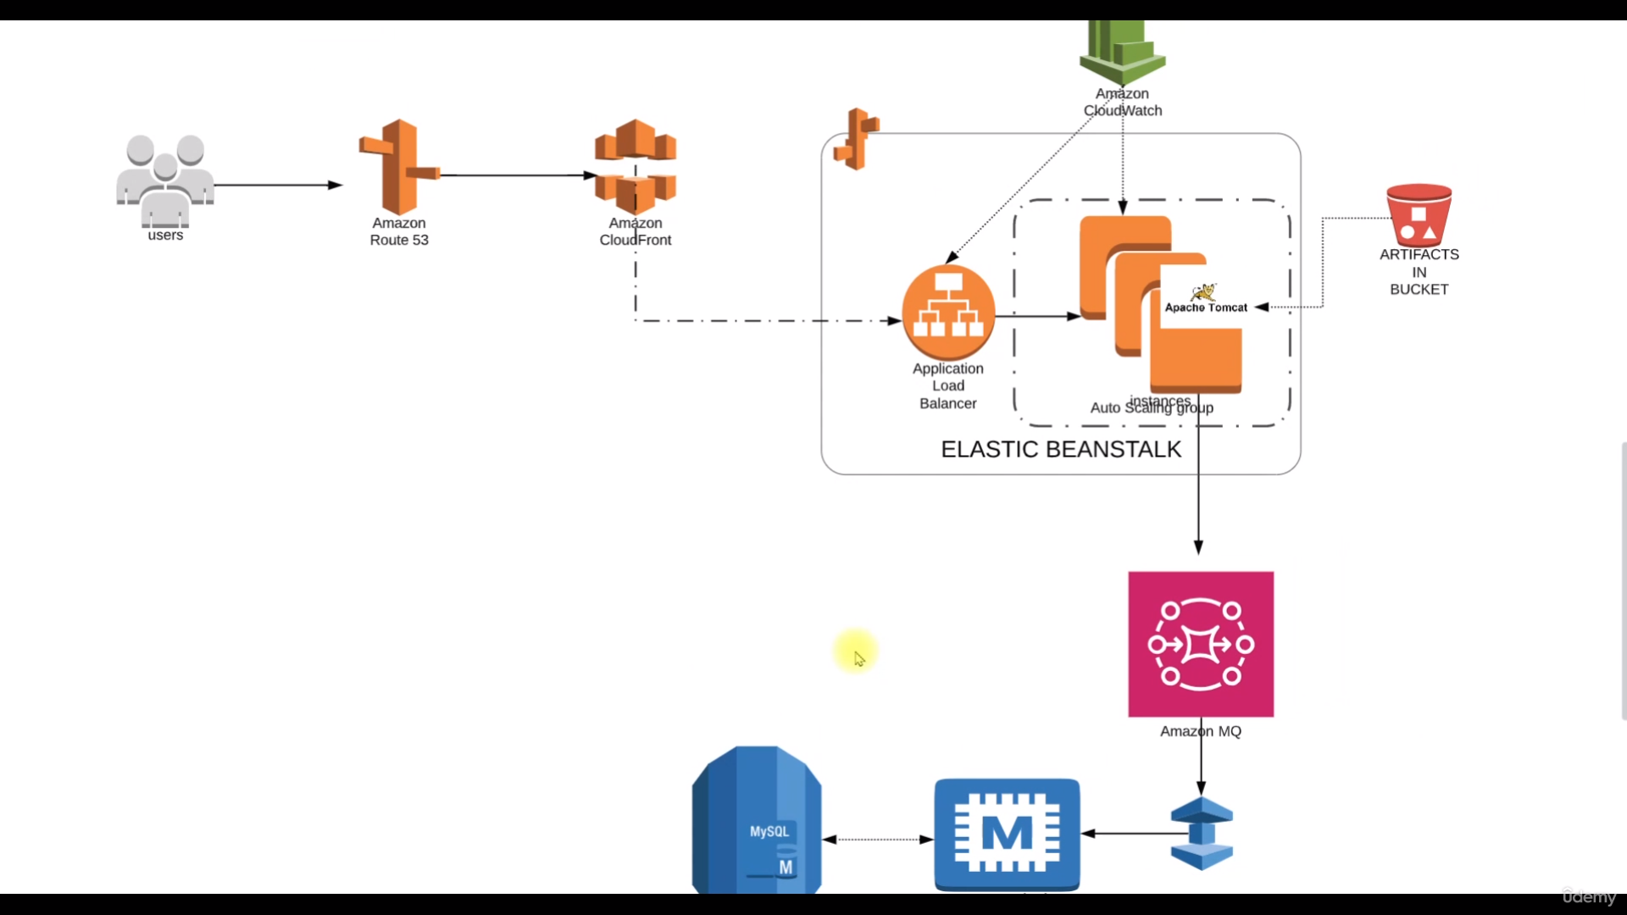

1. Creating Key Pairs:

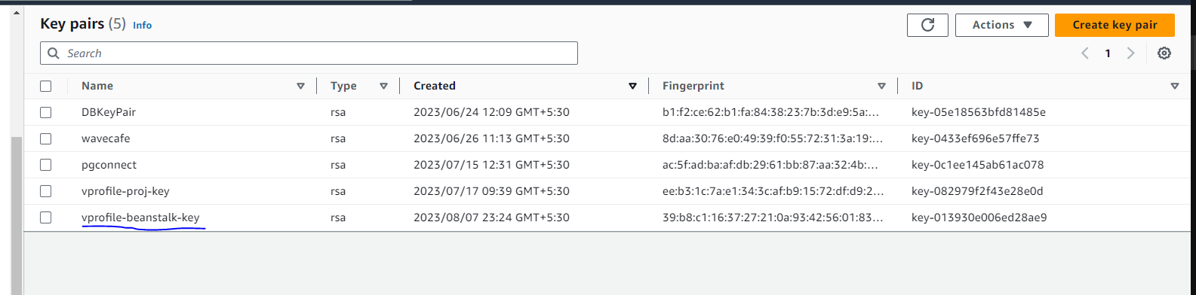

Downloaded the key in pem format. This key will be used to login to temporary instances which are provisioned for configuration set up in the services.

2. Security Group:

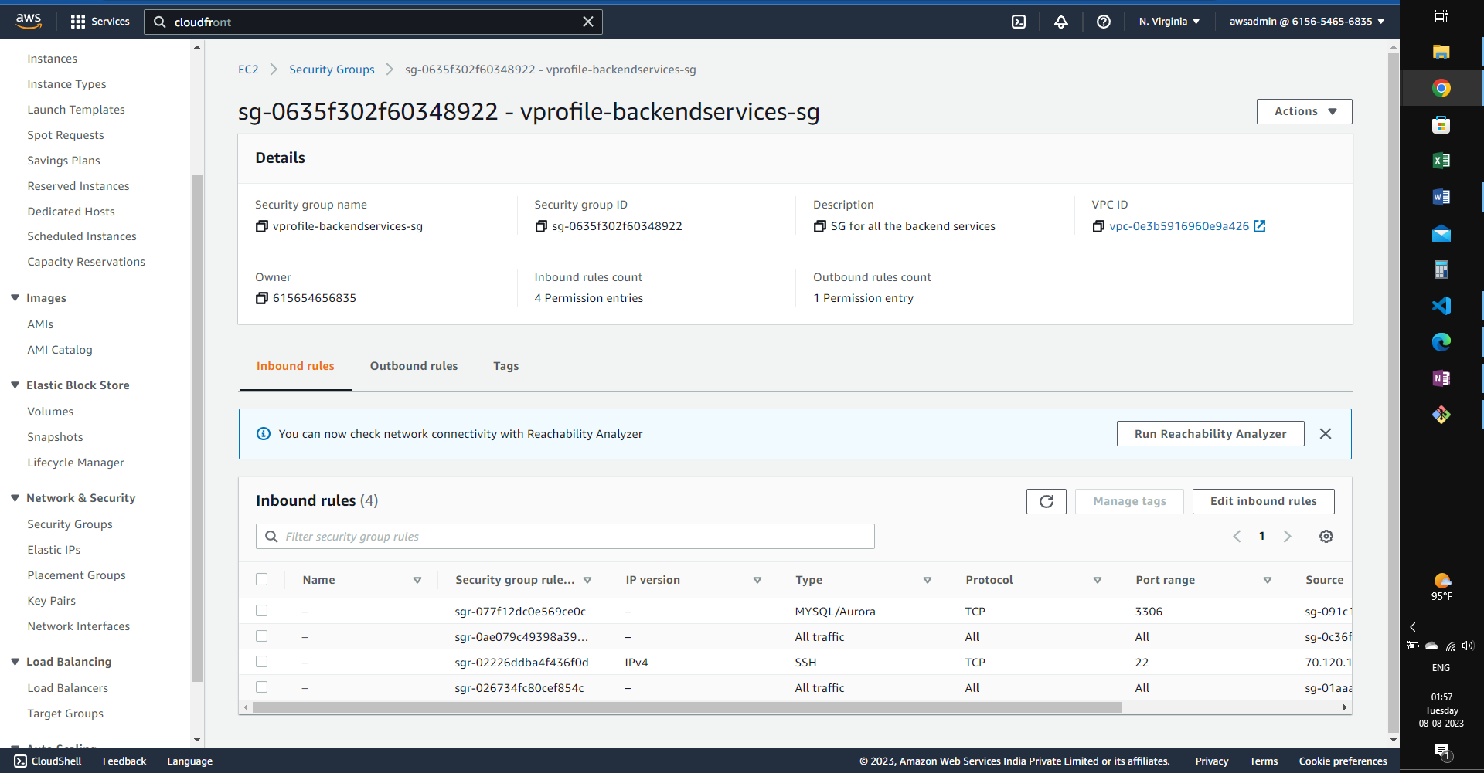

Creating a security group for backend services which are Amazon MQ (Rabbit MQ), Elasticache (Memcached), and RDS (MySQL DB).

# 3. RDS

Creating an RDS for MySQL with the following configurations:

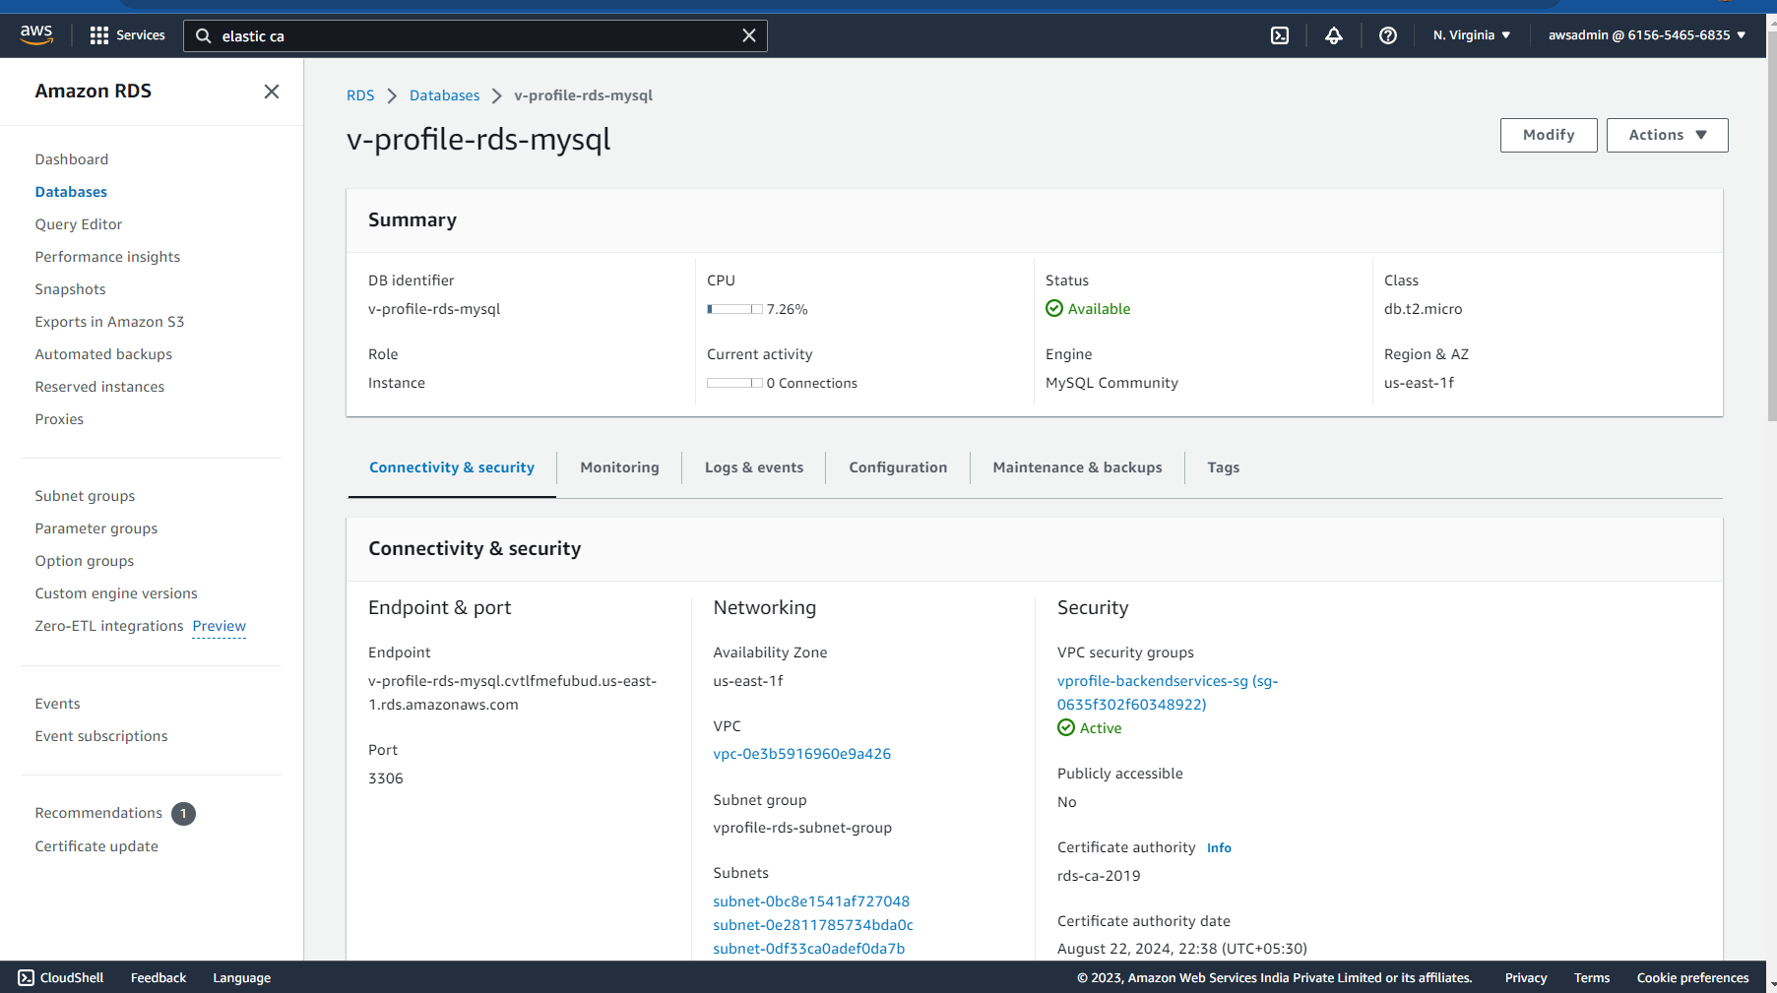

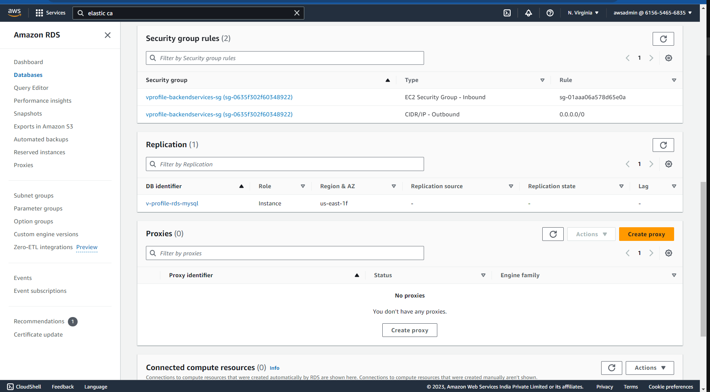

Creating this RDS instance in backend services security group to enable communication between the services and the application.

# 4. Elasticache

Using Elasticache for Memcached functionalities:

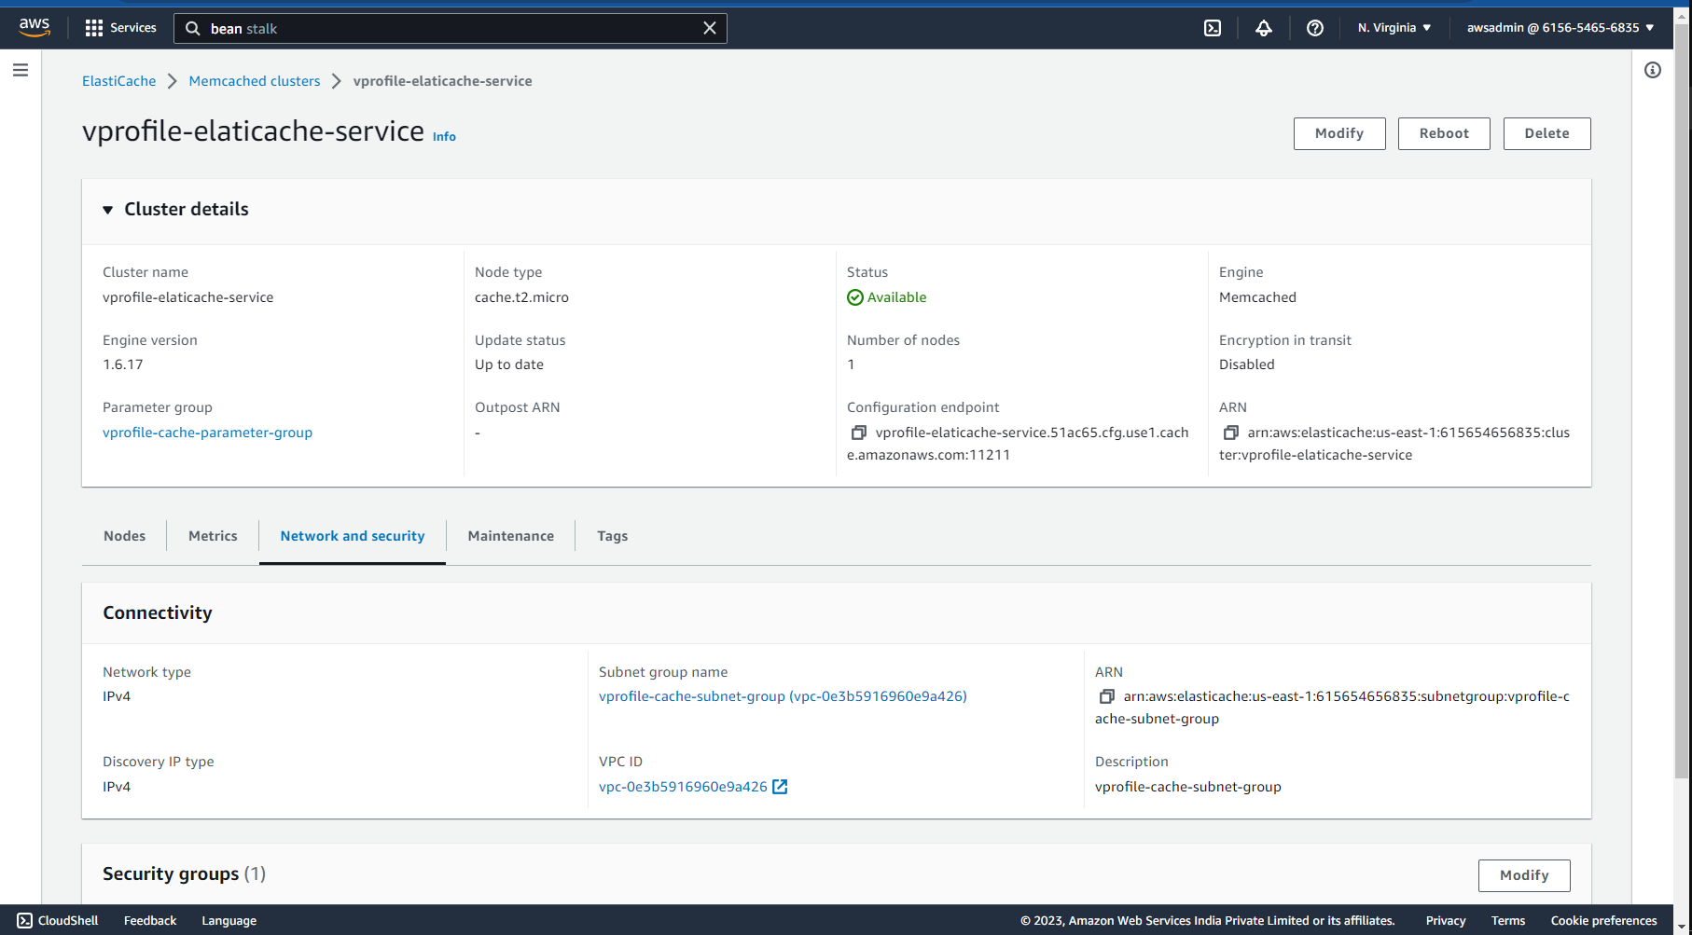

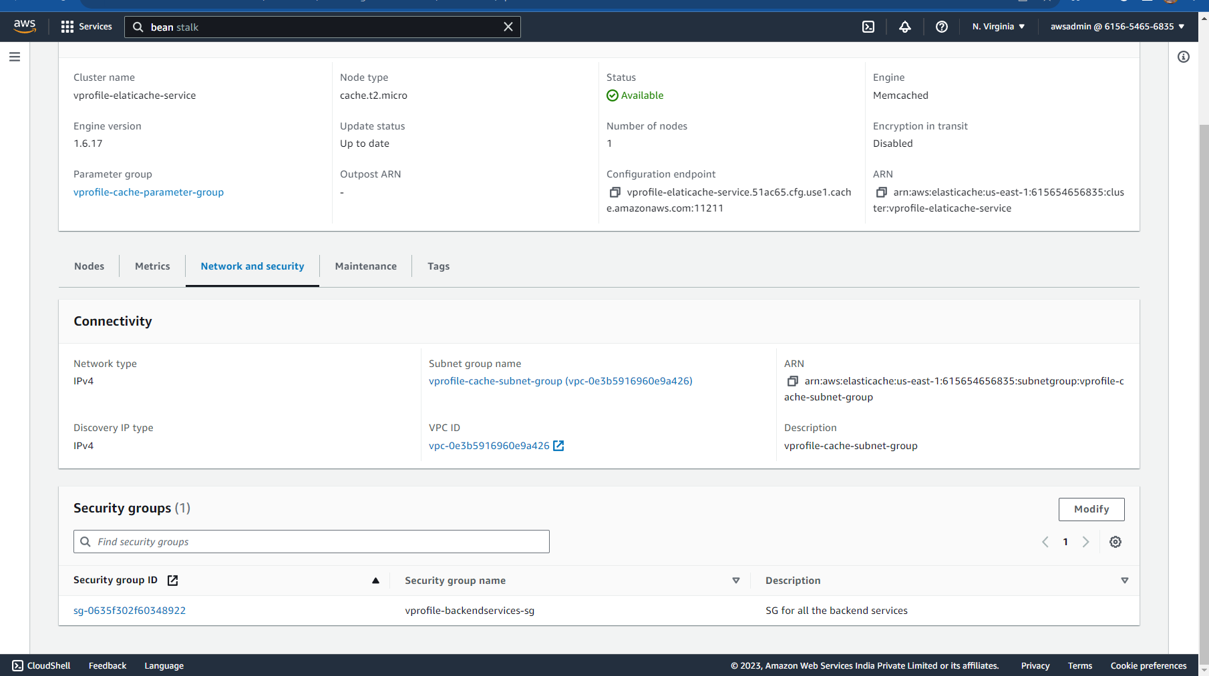

Creating this in the same backend services security group.

# 5. Amazon MQ

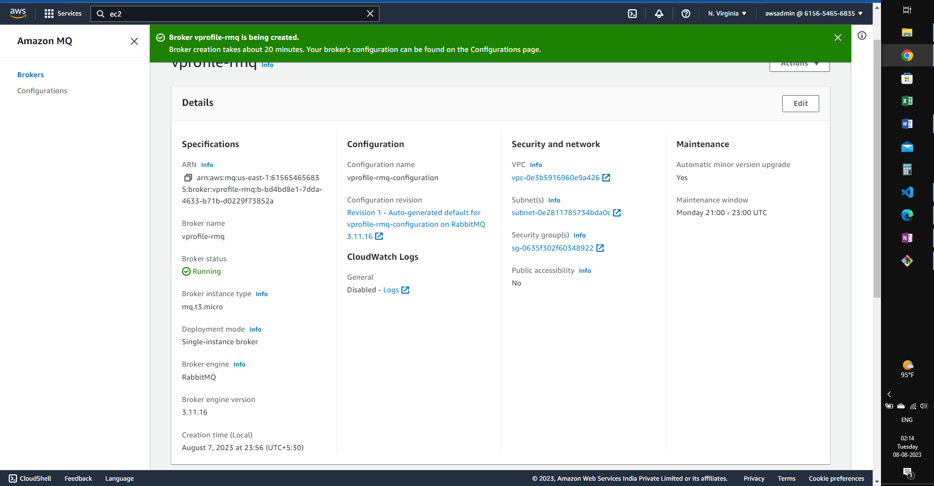

6. Using Elastic Beanstalk:

Deploying the application in beanstalk:

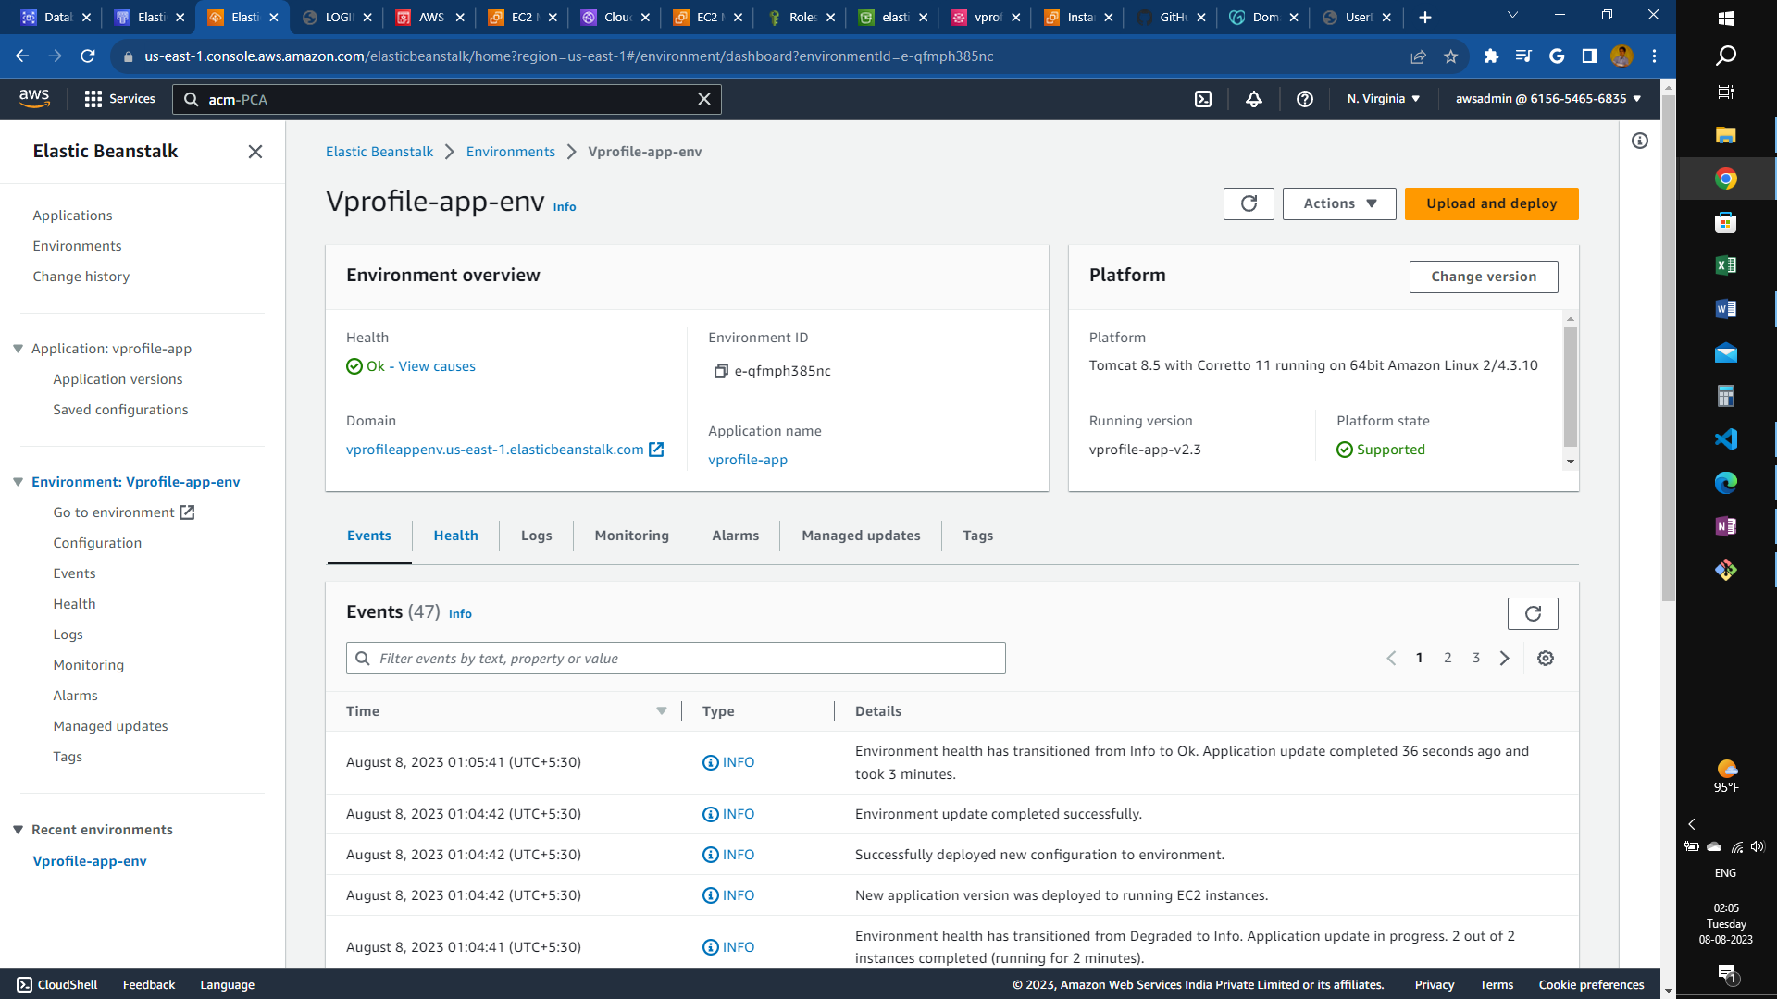

S3 bucket created by Beanstalk:

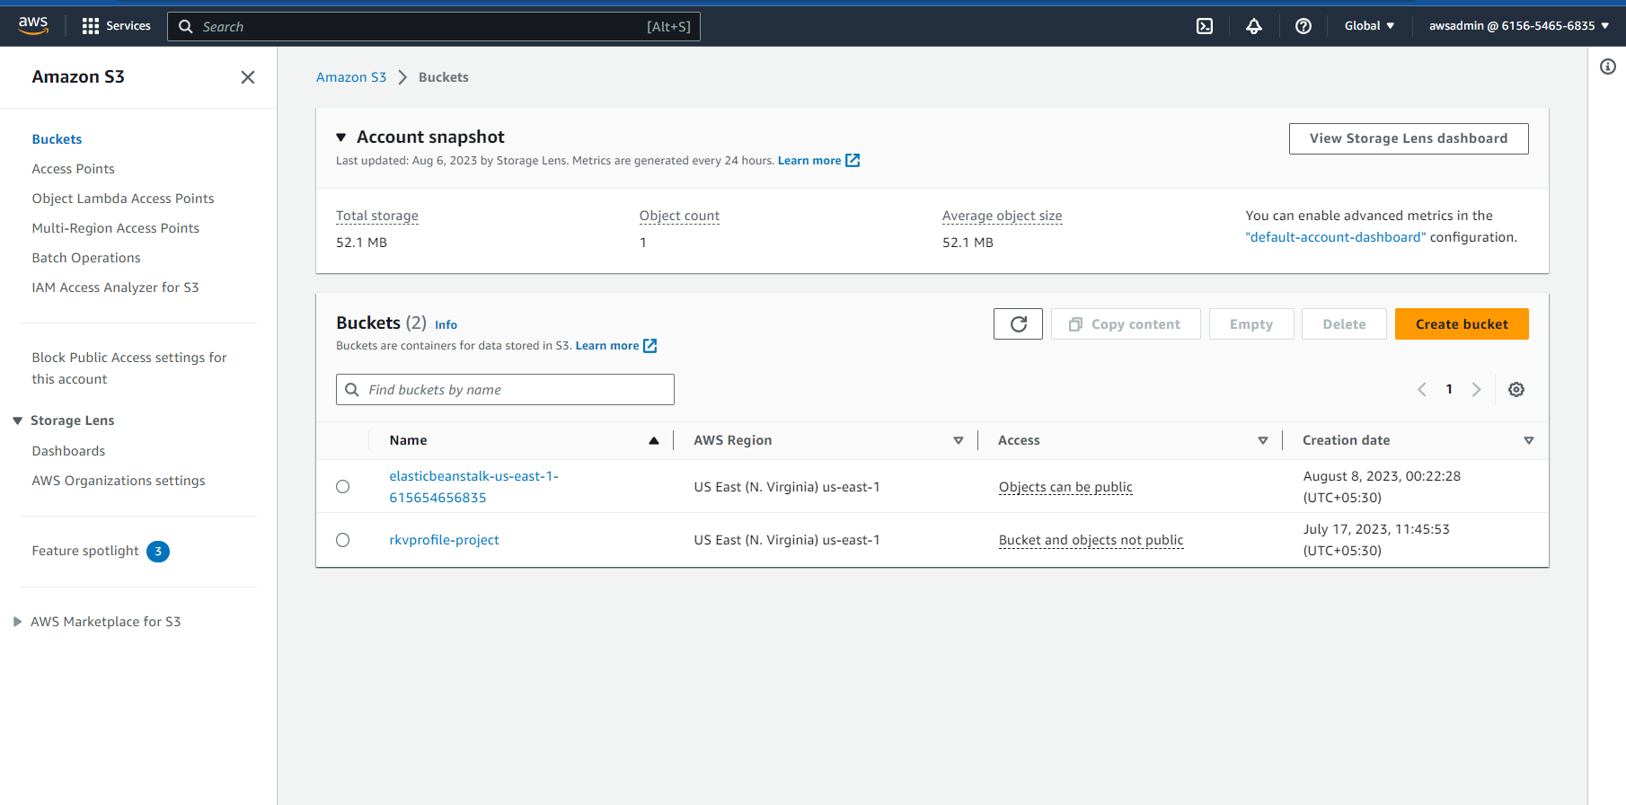

EC2 Instances created by beanstalk:

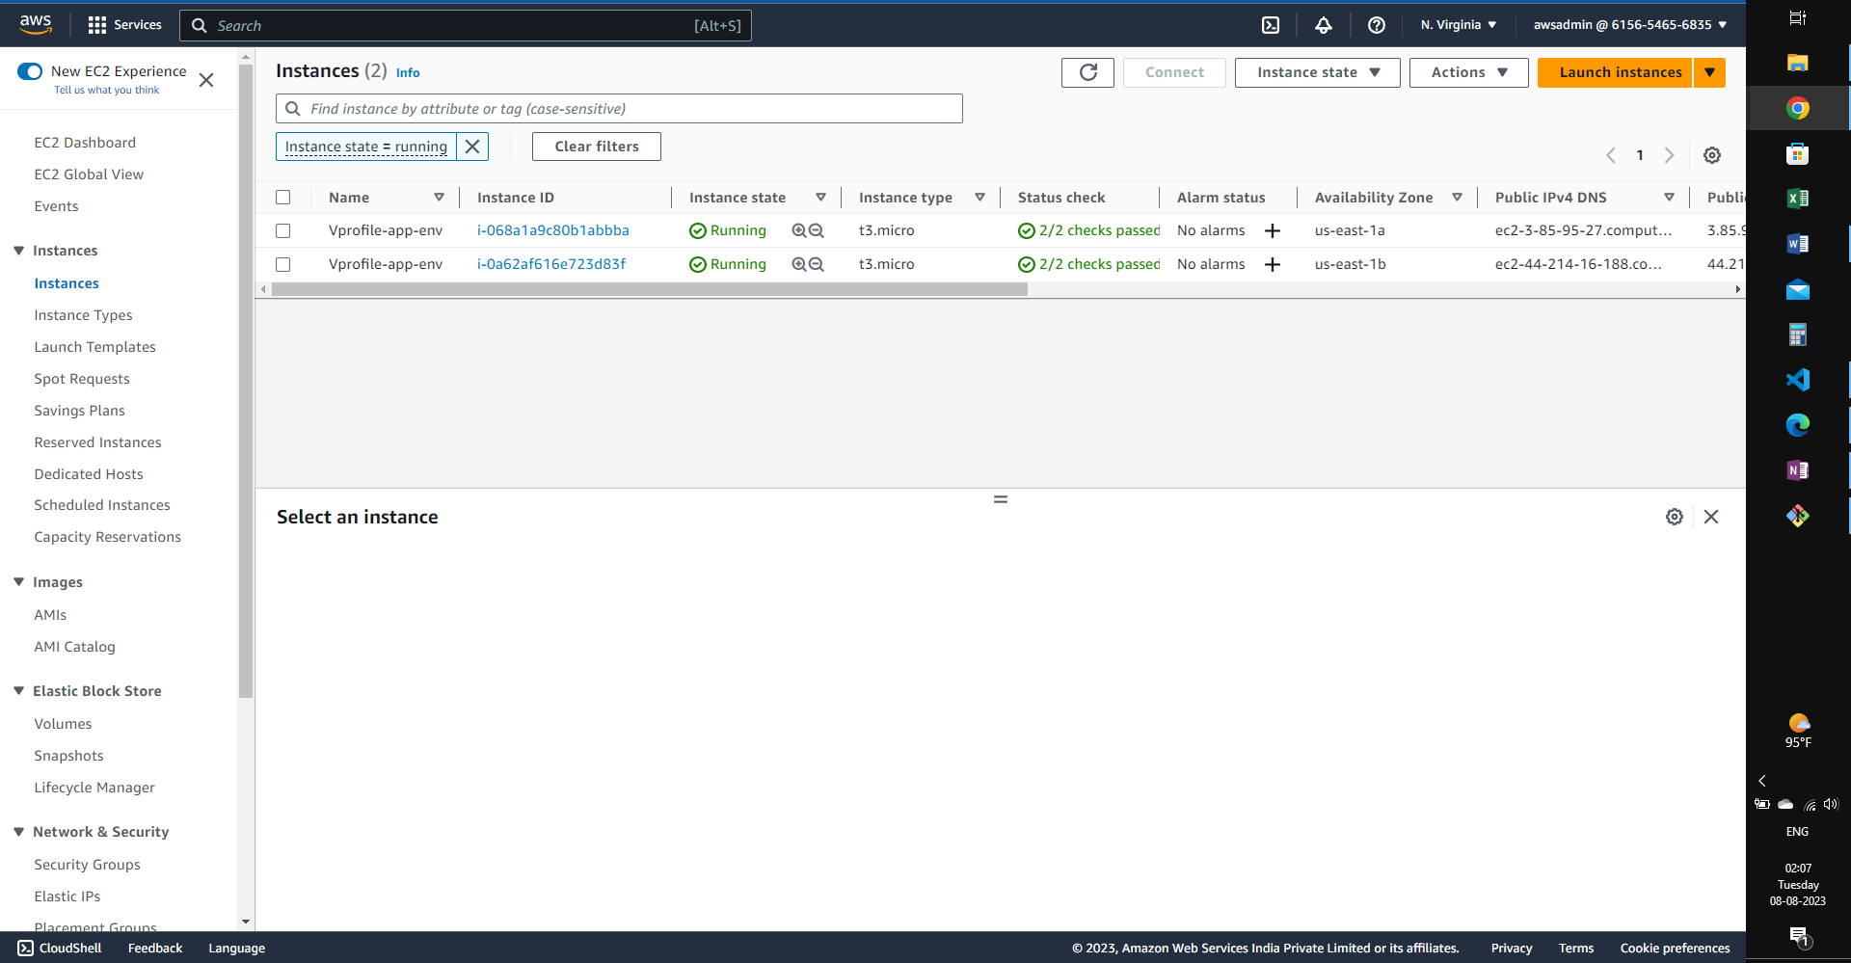

Load Balancer created by Beanstalk:

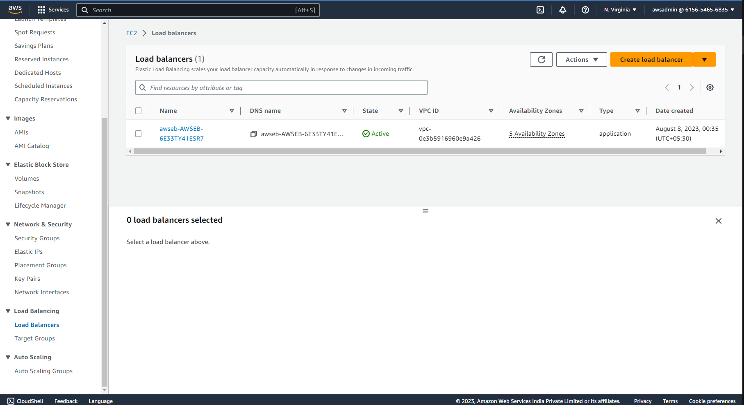

Target groups created by Beanstalk:

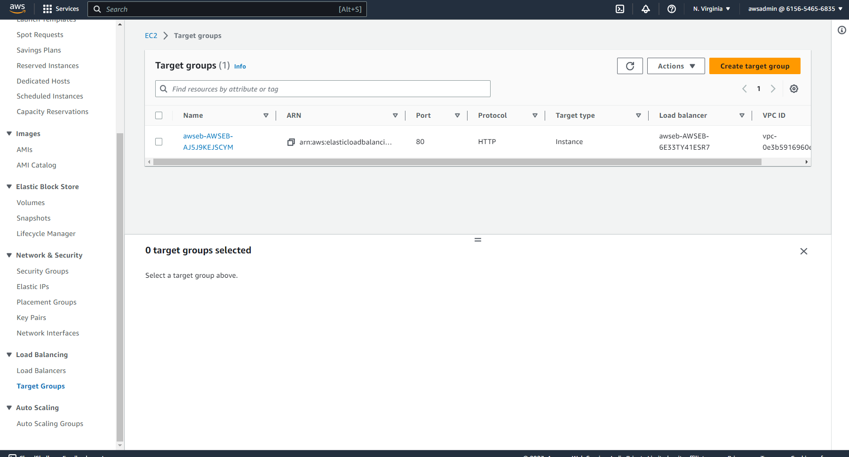

Autoscaling group created by beanstalk:

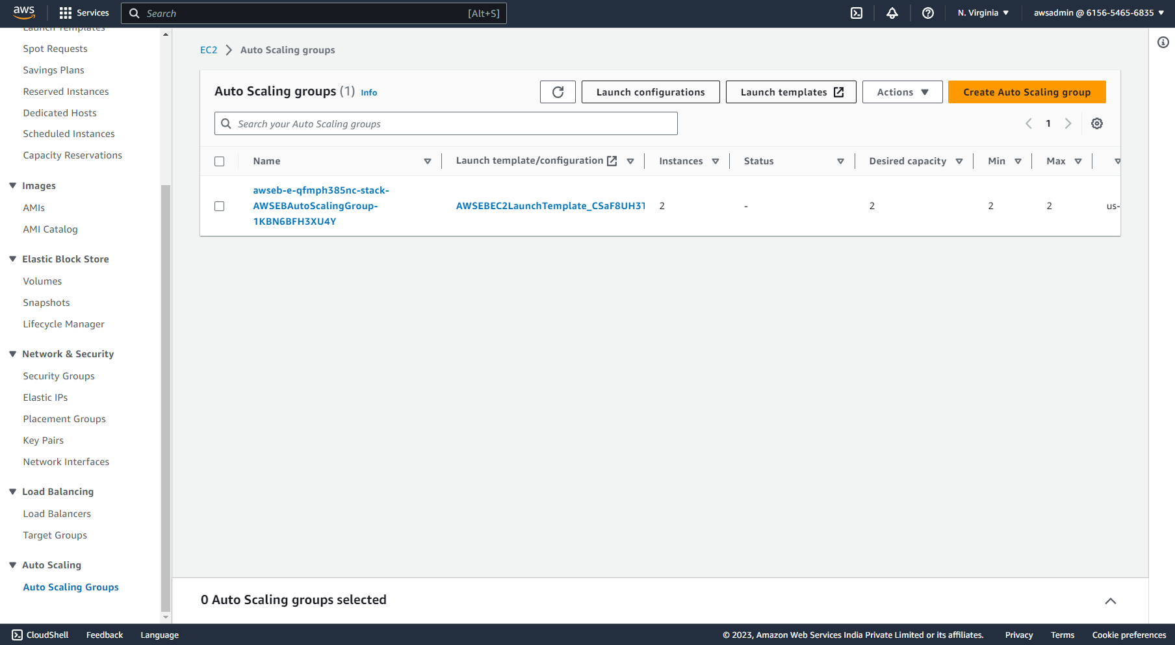

Security groups created by Load Balancer:

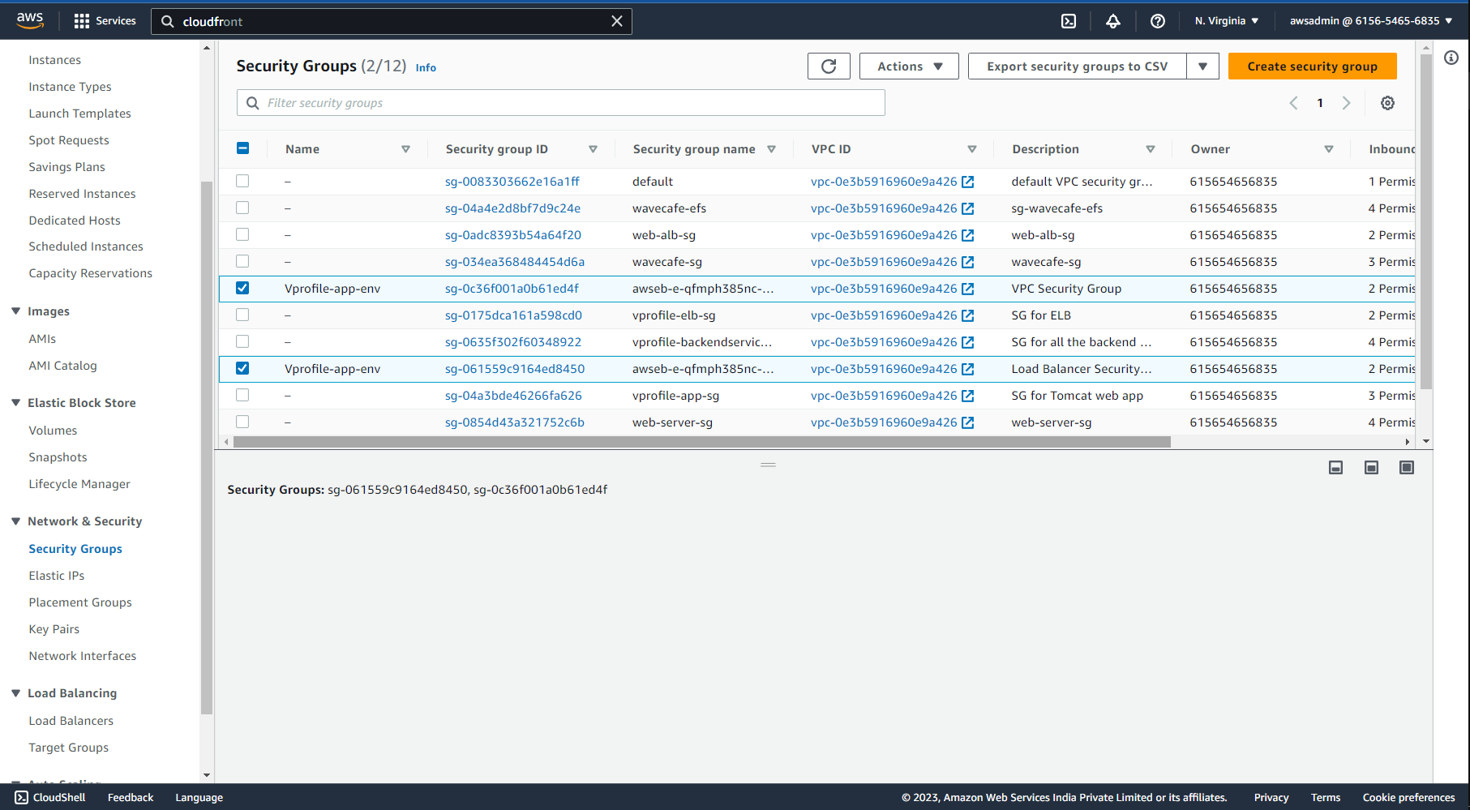

Additional IAM Role for Beanstalk:

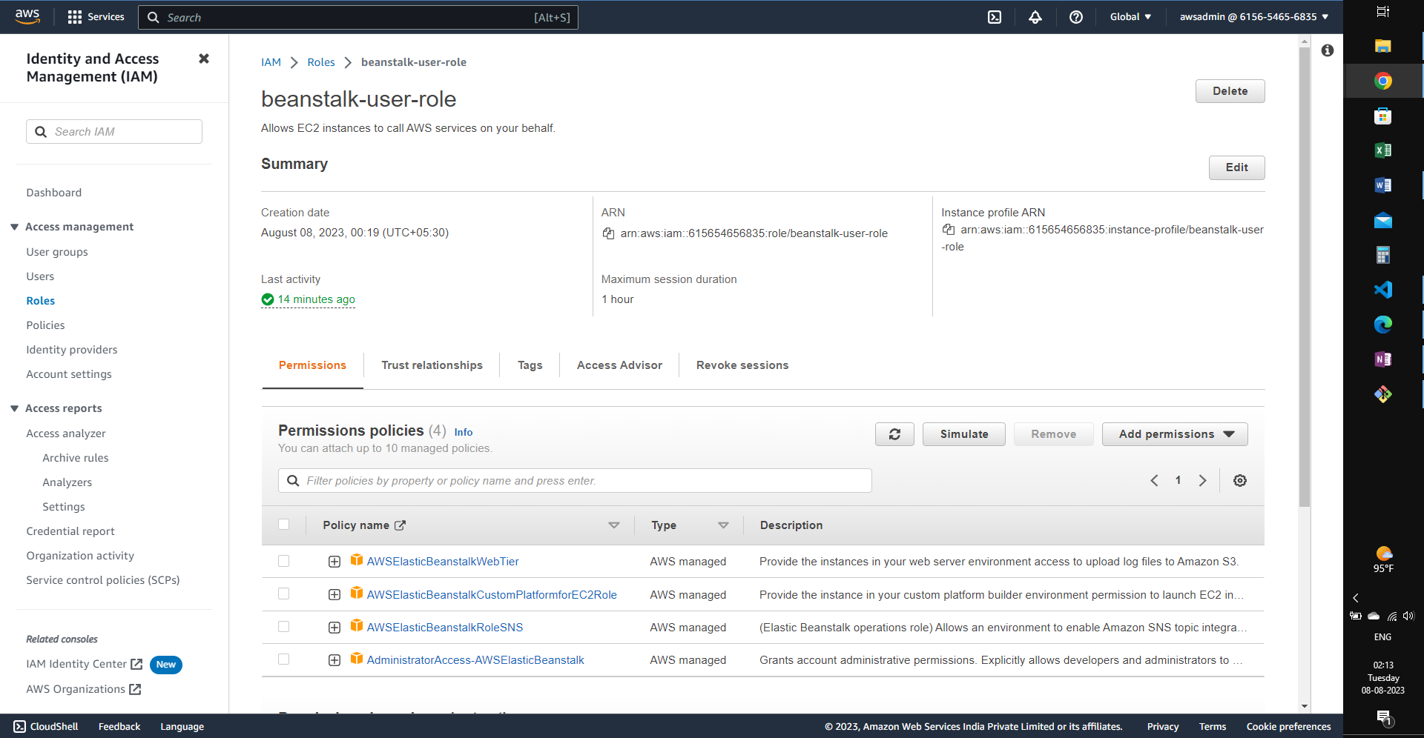

Application Deployed through Beanstalk:

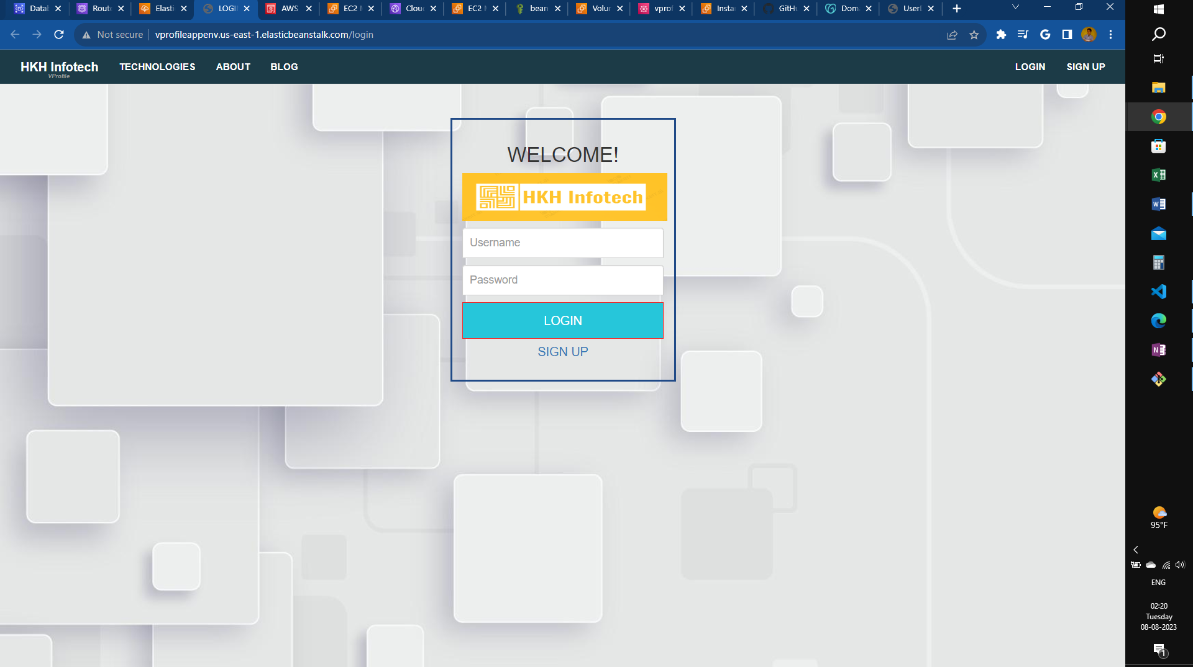

Note the SSL security missing for the application.

# 7. GoDaddy record creation for the domain

Creating a CNAME record for the Beanstalk URL:

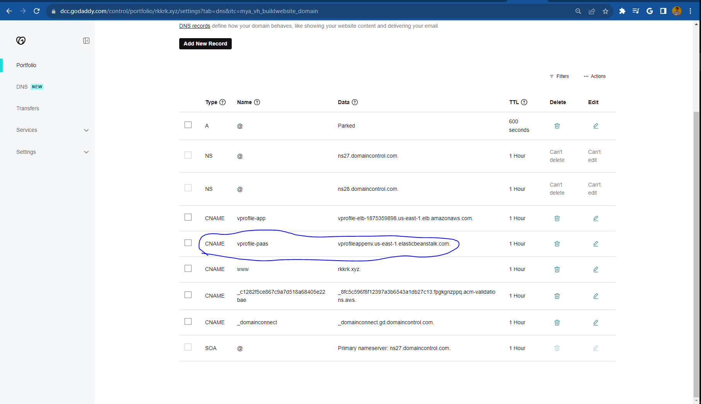

Secure Application:

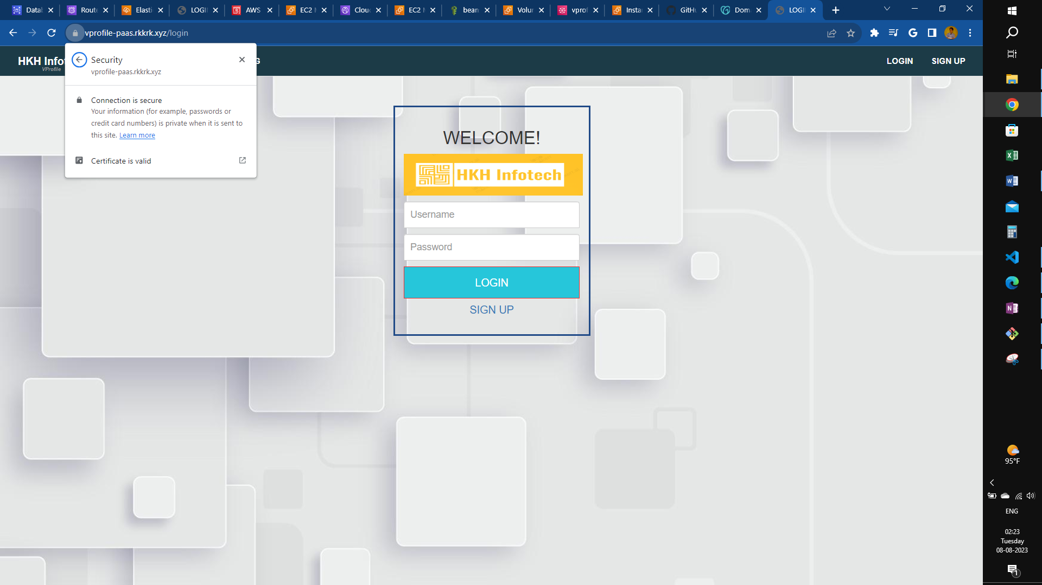

# 8. Cloudfront distribution for the application:

